**RESULTS**

1. **Data Pre-processing:** This step involves assigning feature names in the csv files, since the data was completely Raw.
2. **Data Visualisation**
   1. **RIPE-BCNET_Regular**

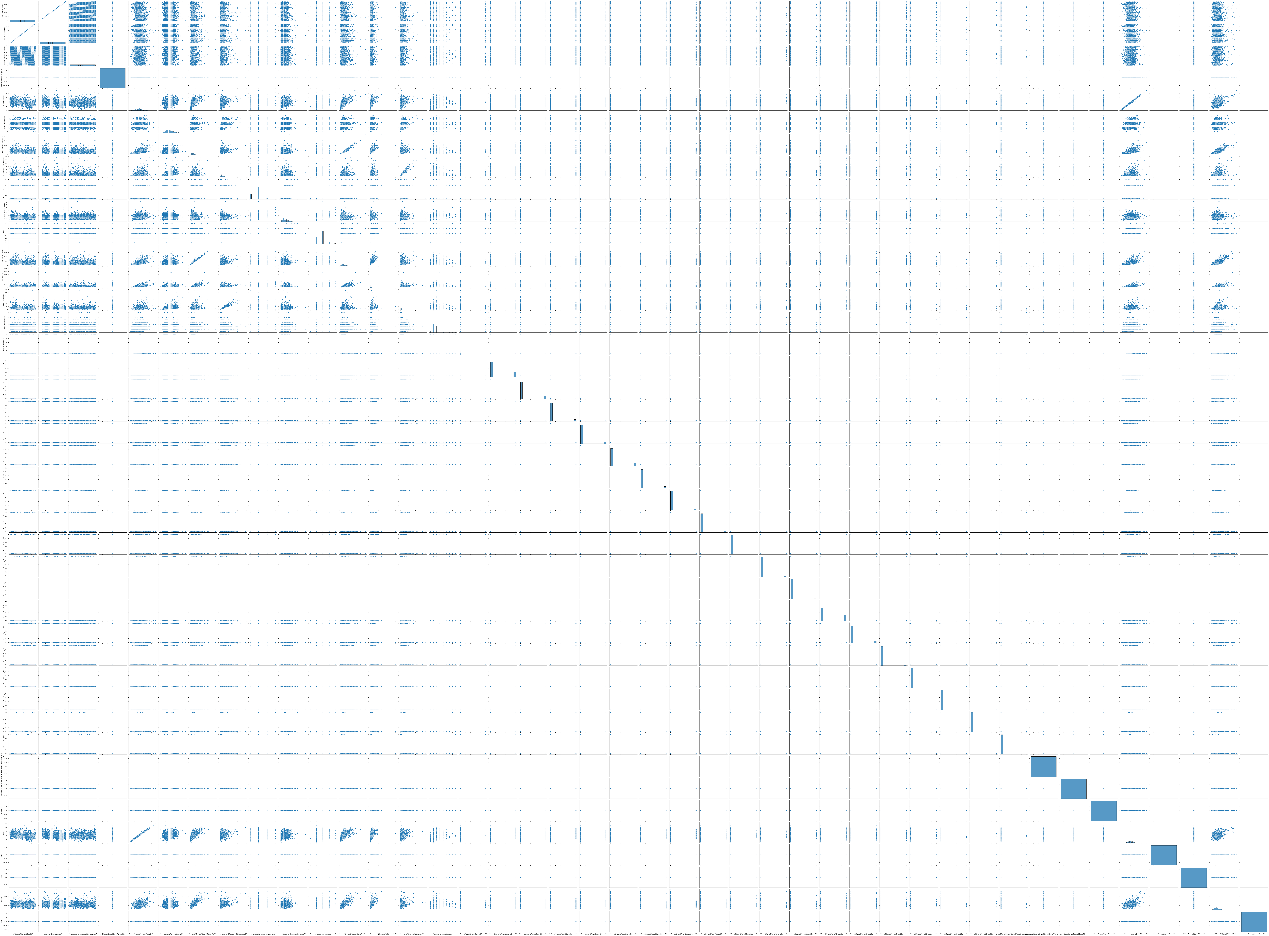

Figure 1: Visualizing the relationships between all features of the dataset using seaborn library of python

* 1. **RIPE-Code_Red_I**

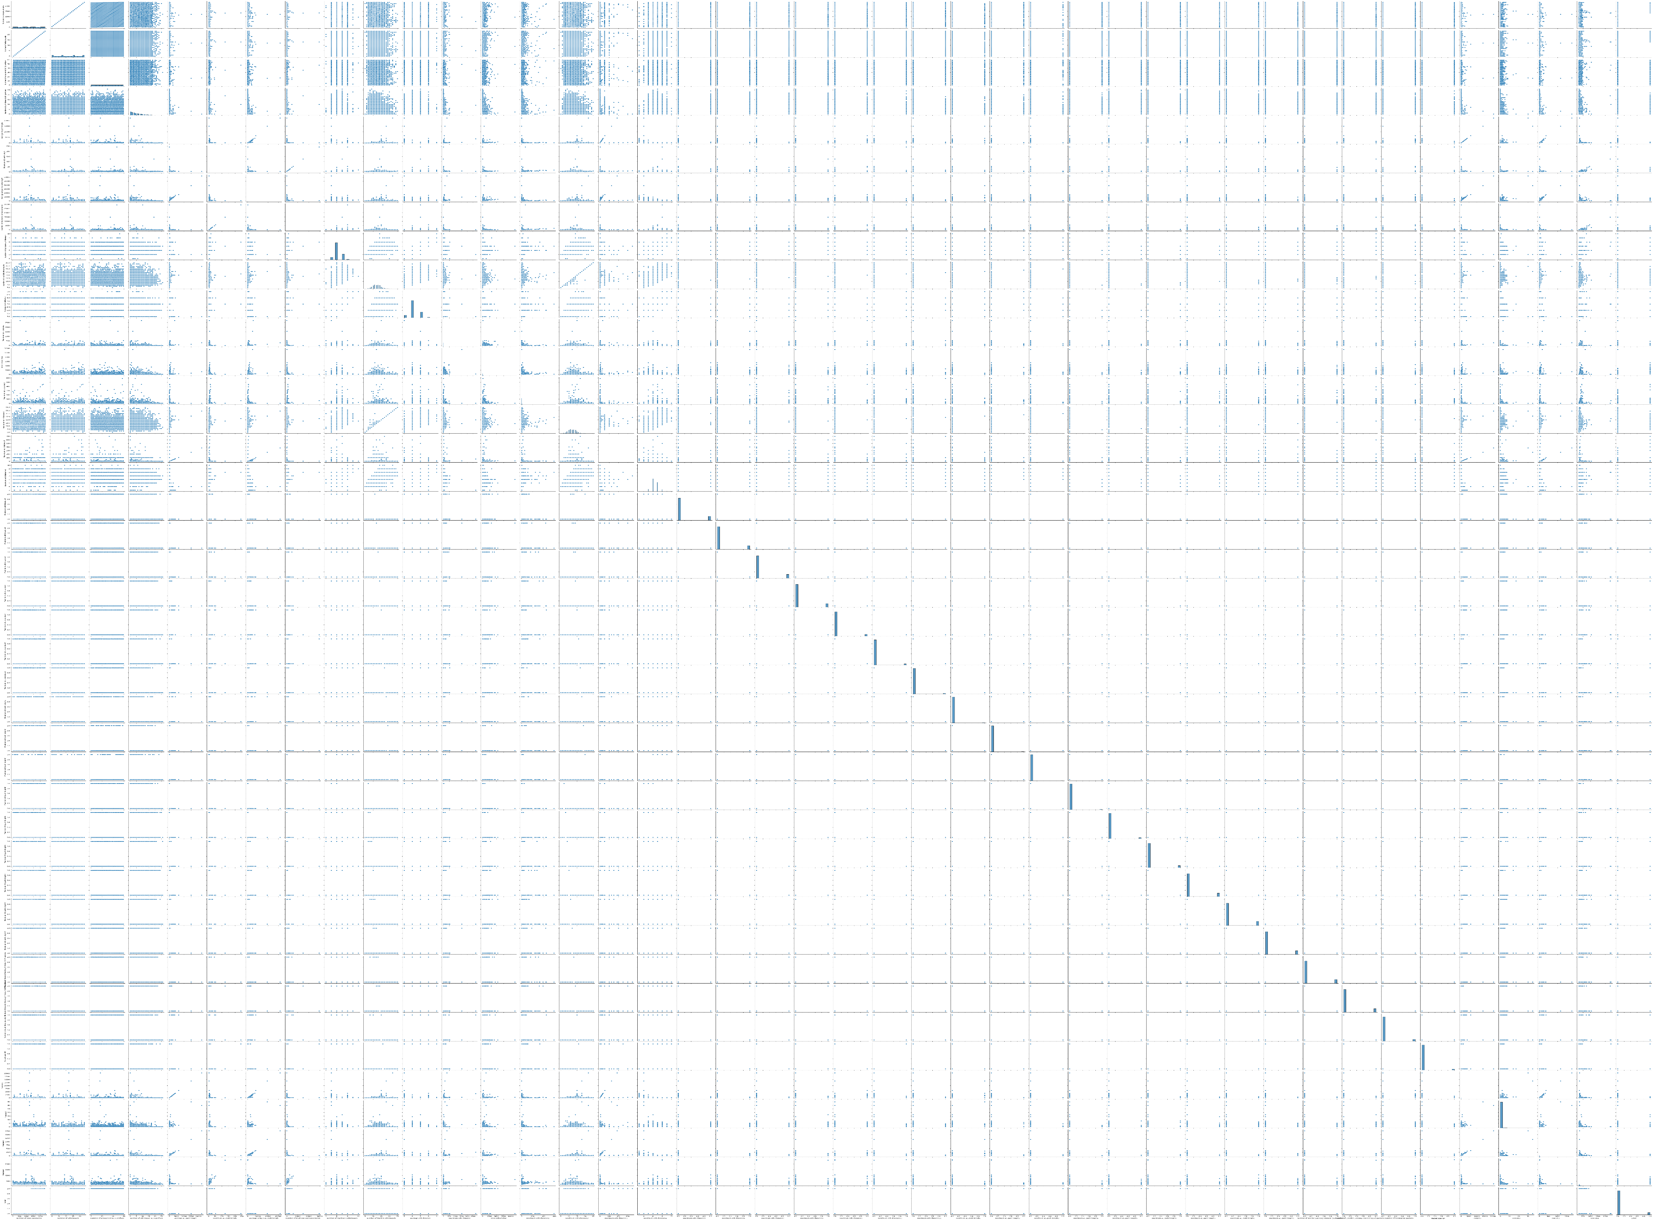

Figure 2: Visualizing the relationships between all features of the dataset using seaborn library of python

* 1. **RIPE_Moscow_blackout**

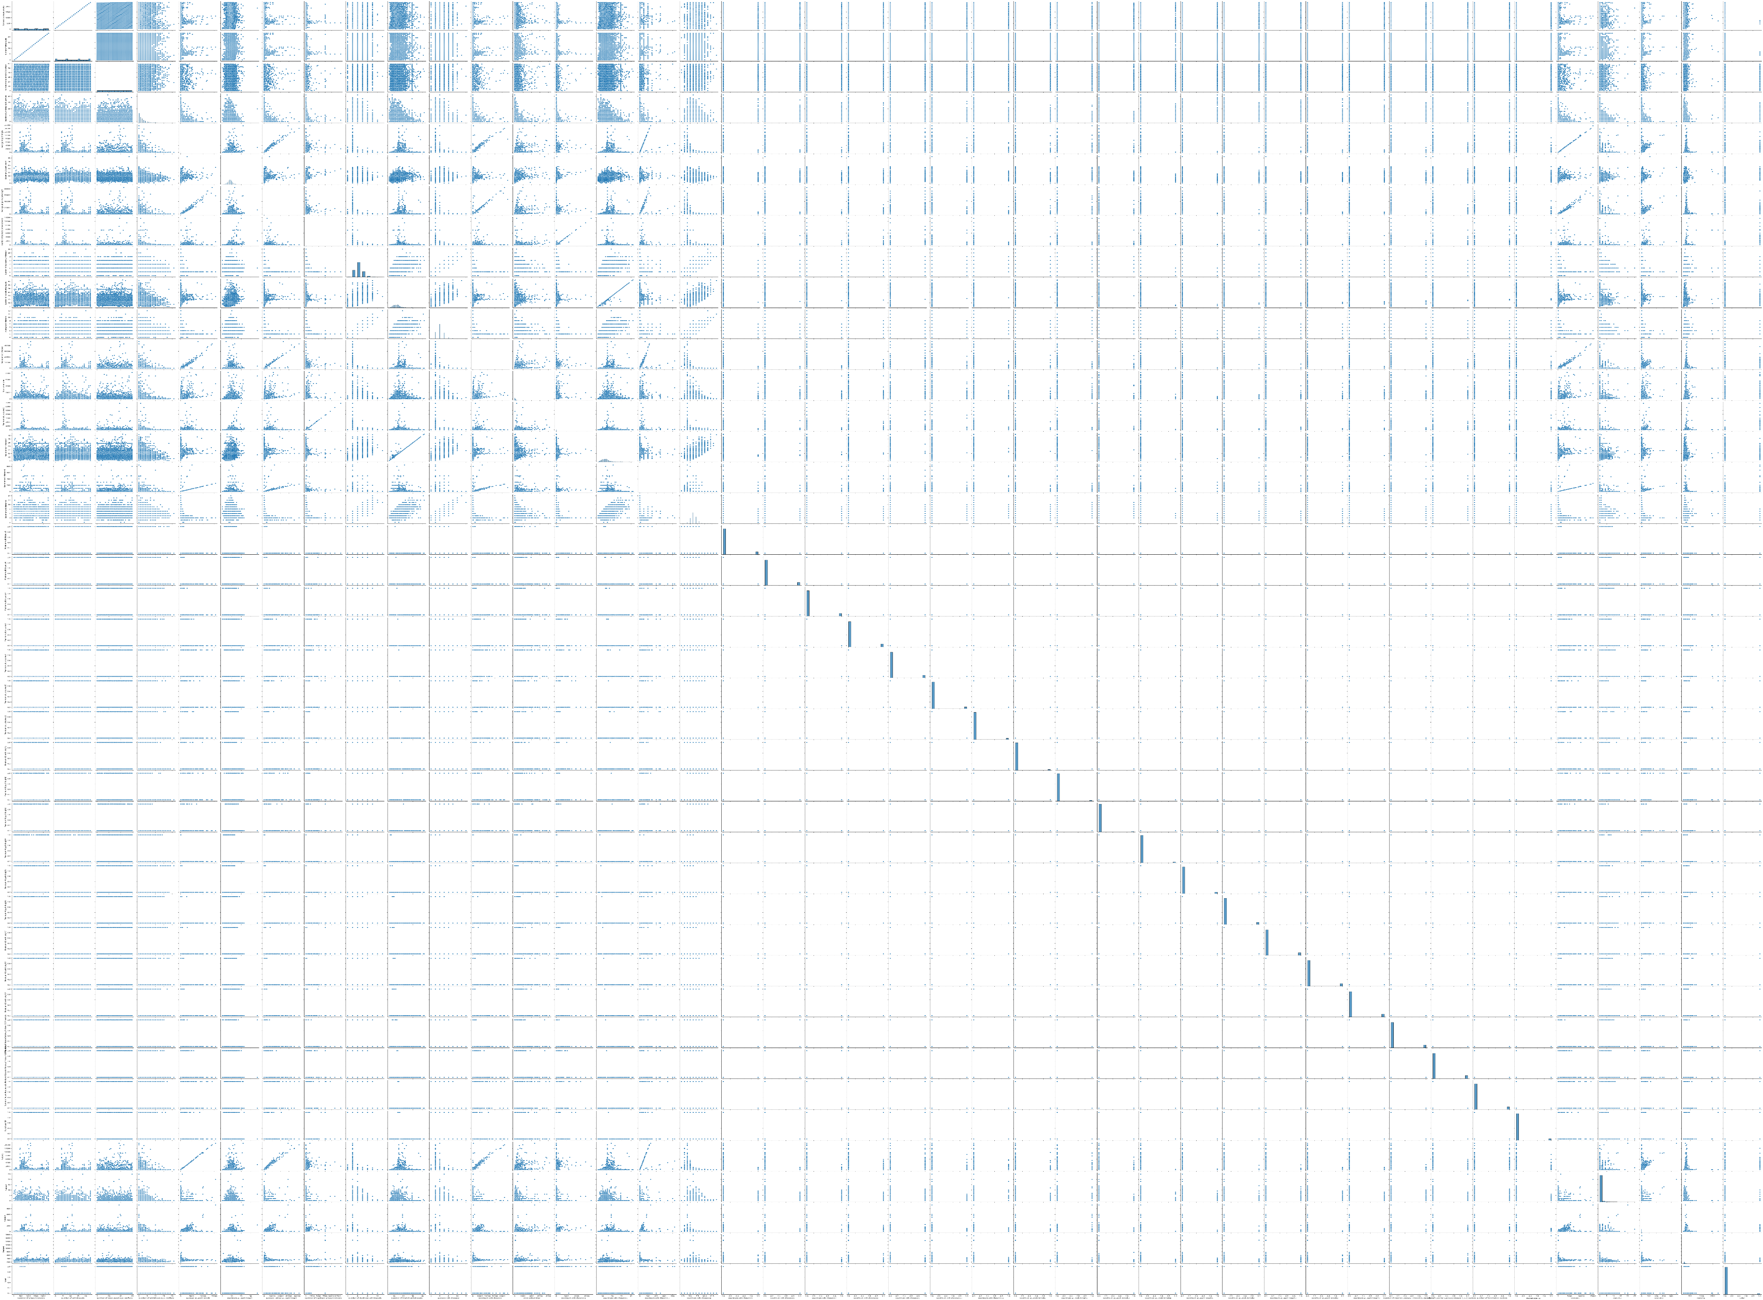

Figure 3: Visualizing the relationships between all features of the dataset using seaborn library of python

* 1. **RIPE_Nimda**

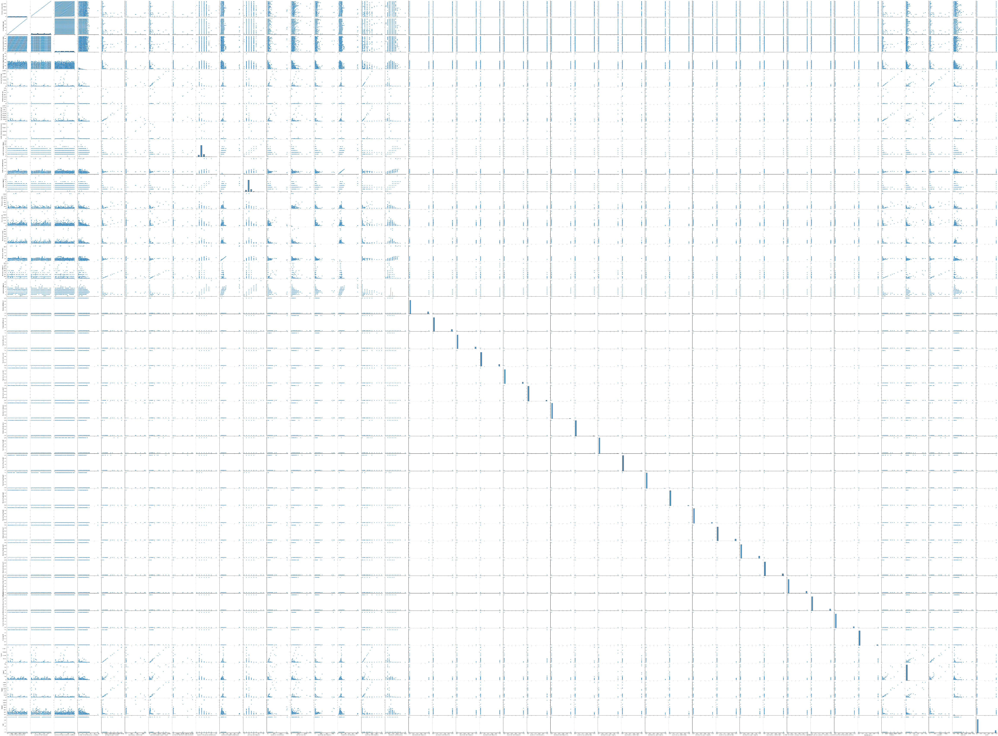

Figure 4: Visualizing the relationships between all features of the dataset using seaborn library of python

* 1. **RIPE_regular**

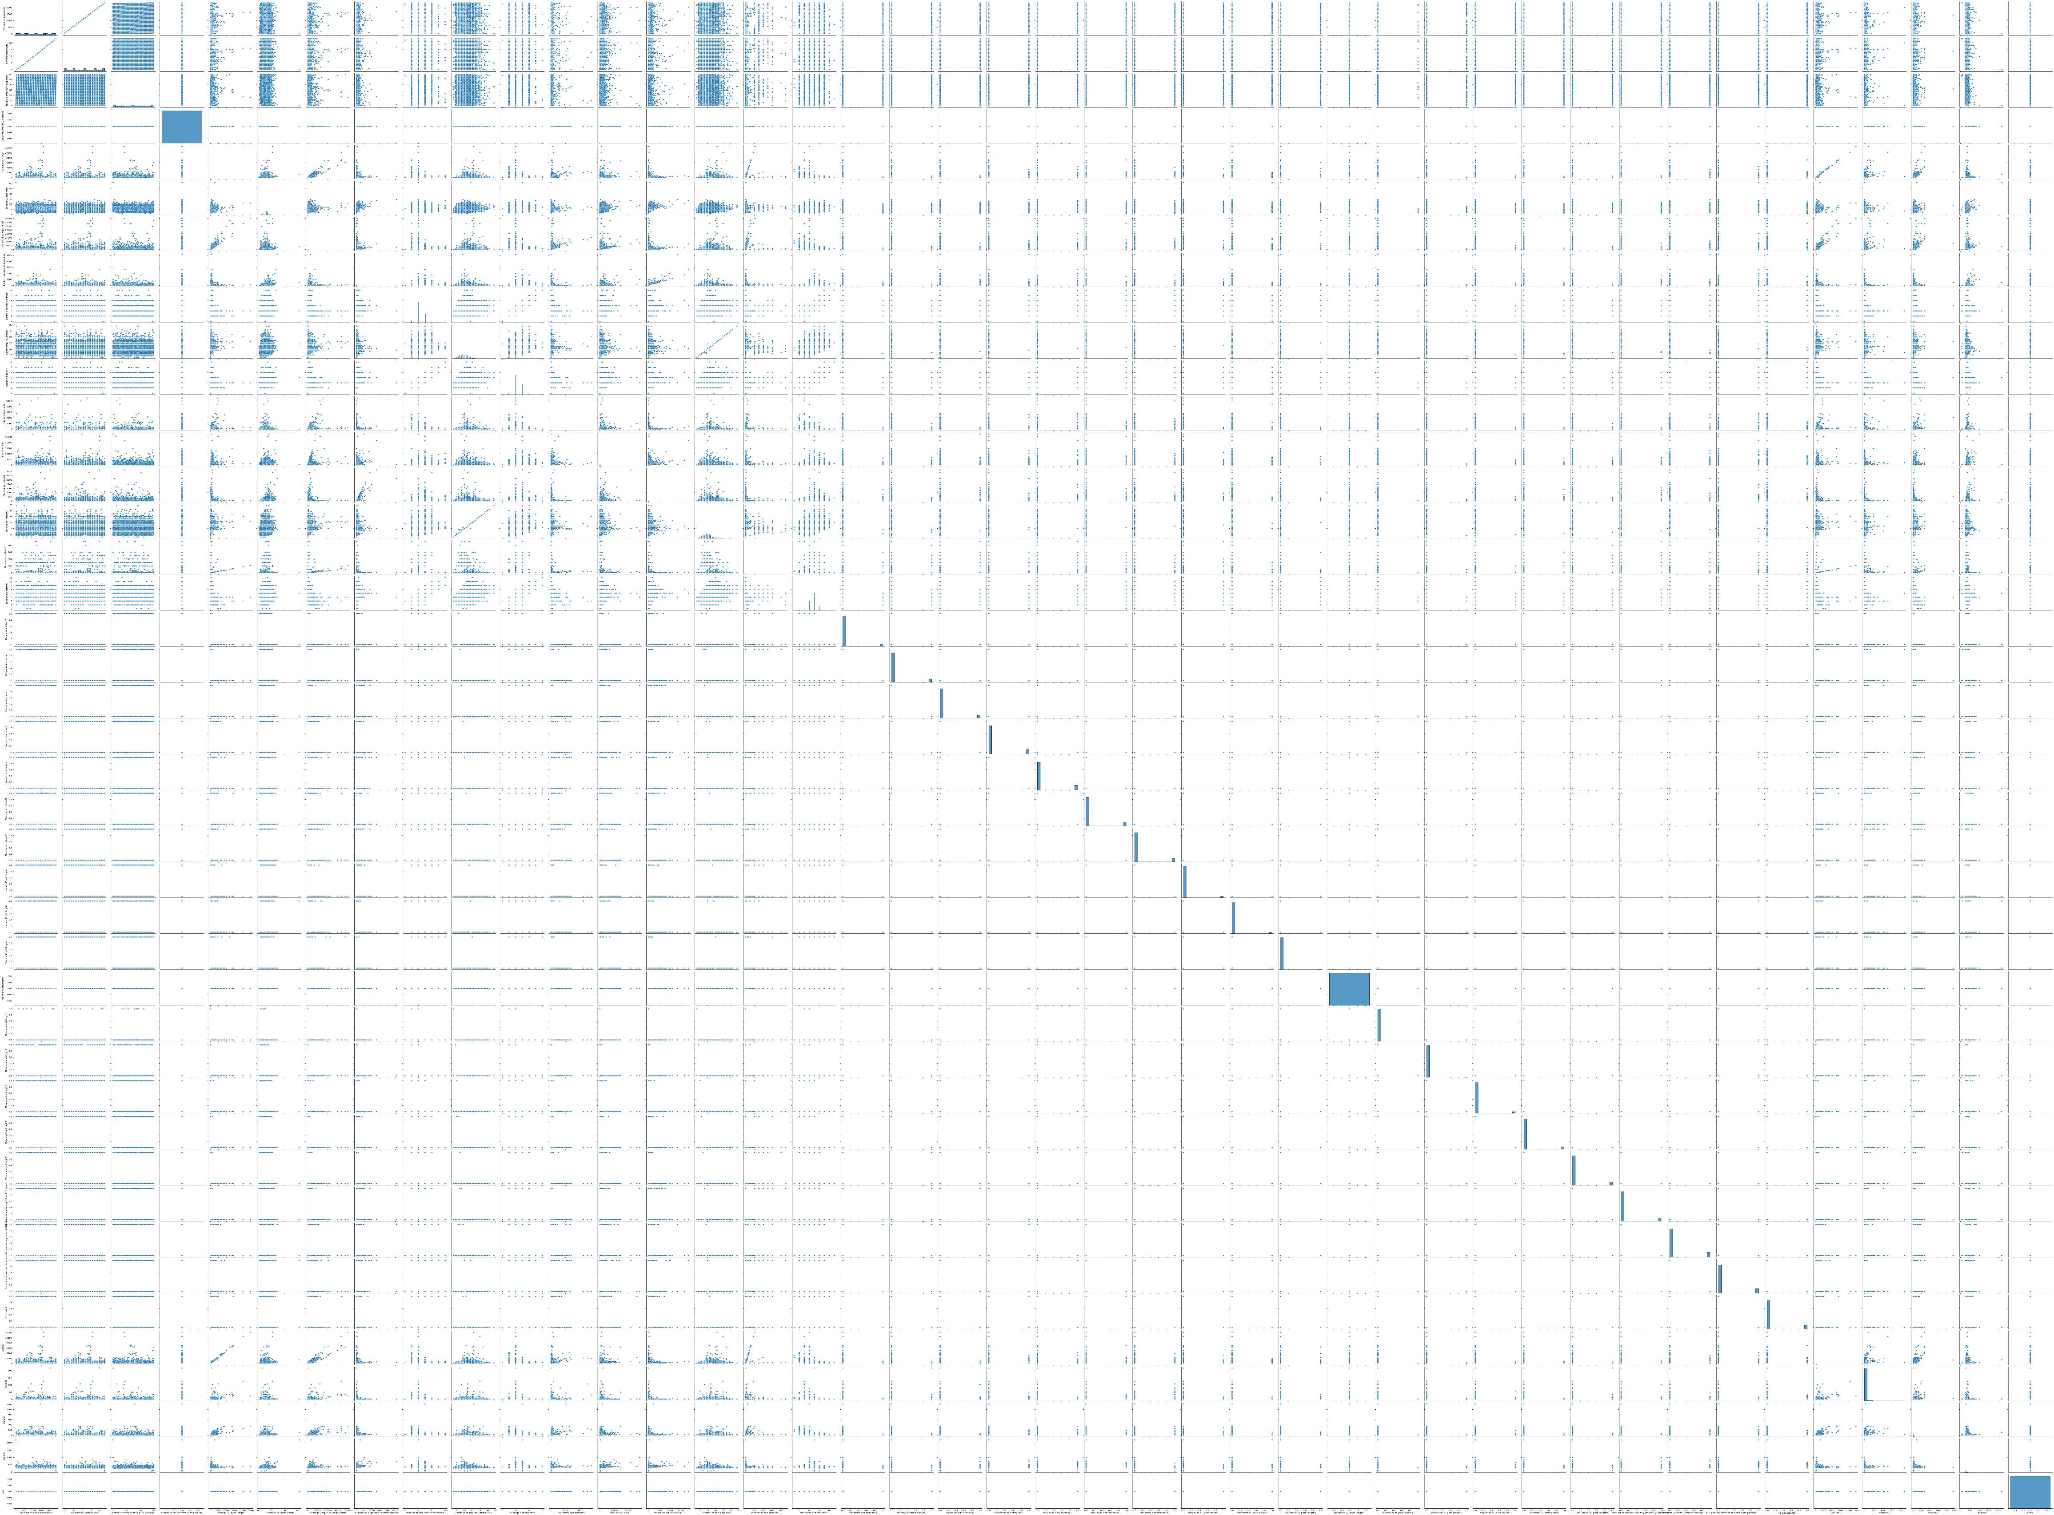

Figure 5: Visualizing the relationships between all features of the dataset using seaborn library of python

* 1. **RIPE_Slammer**

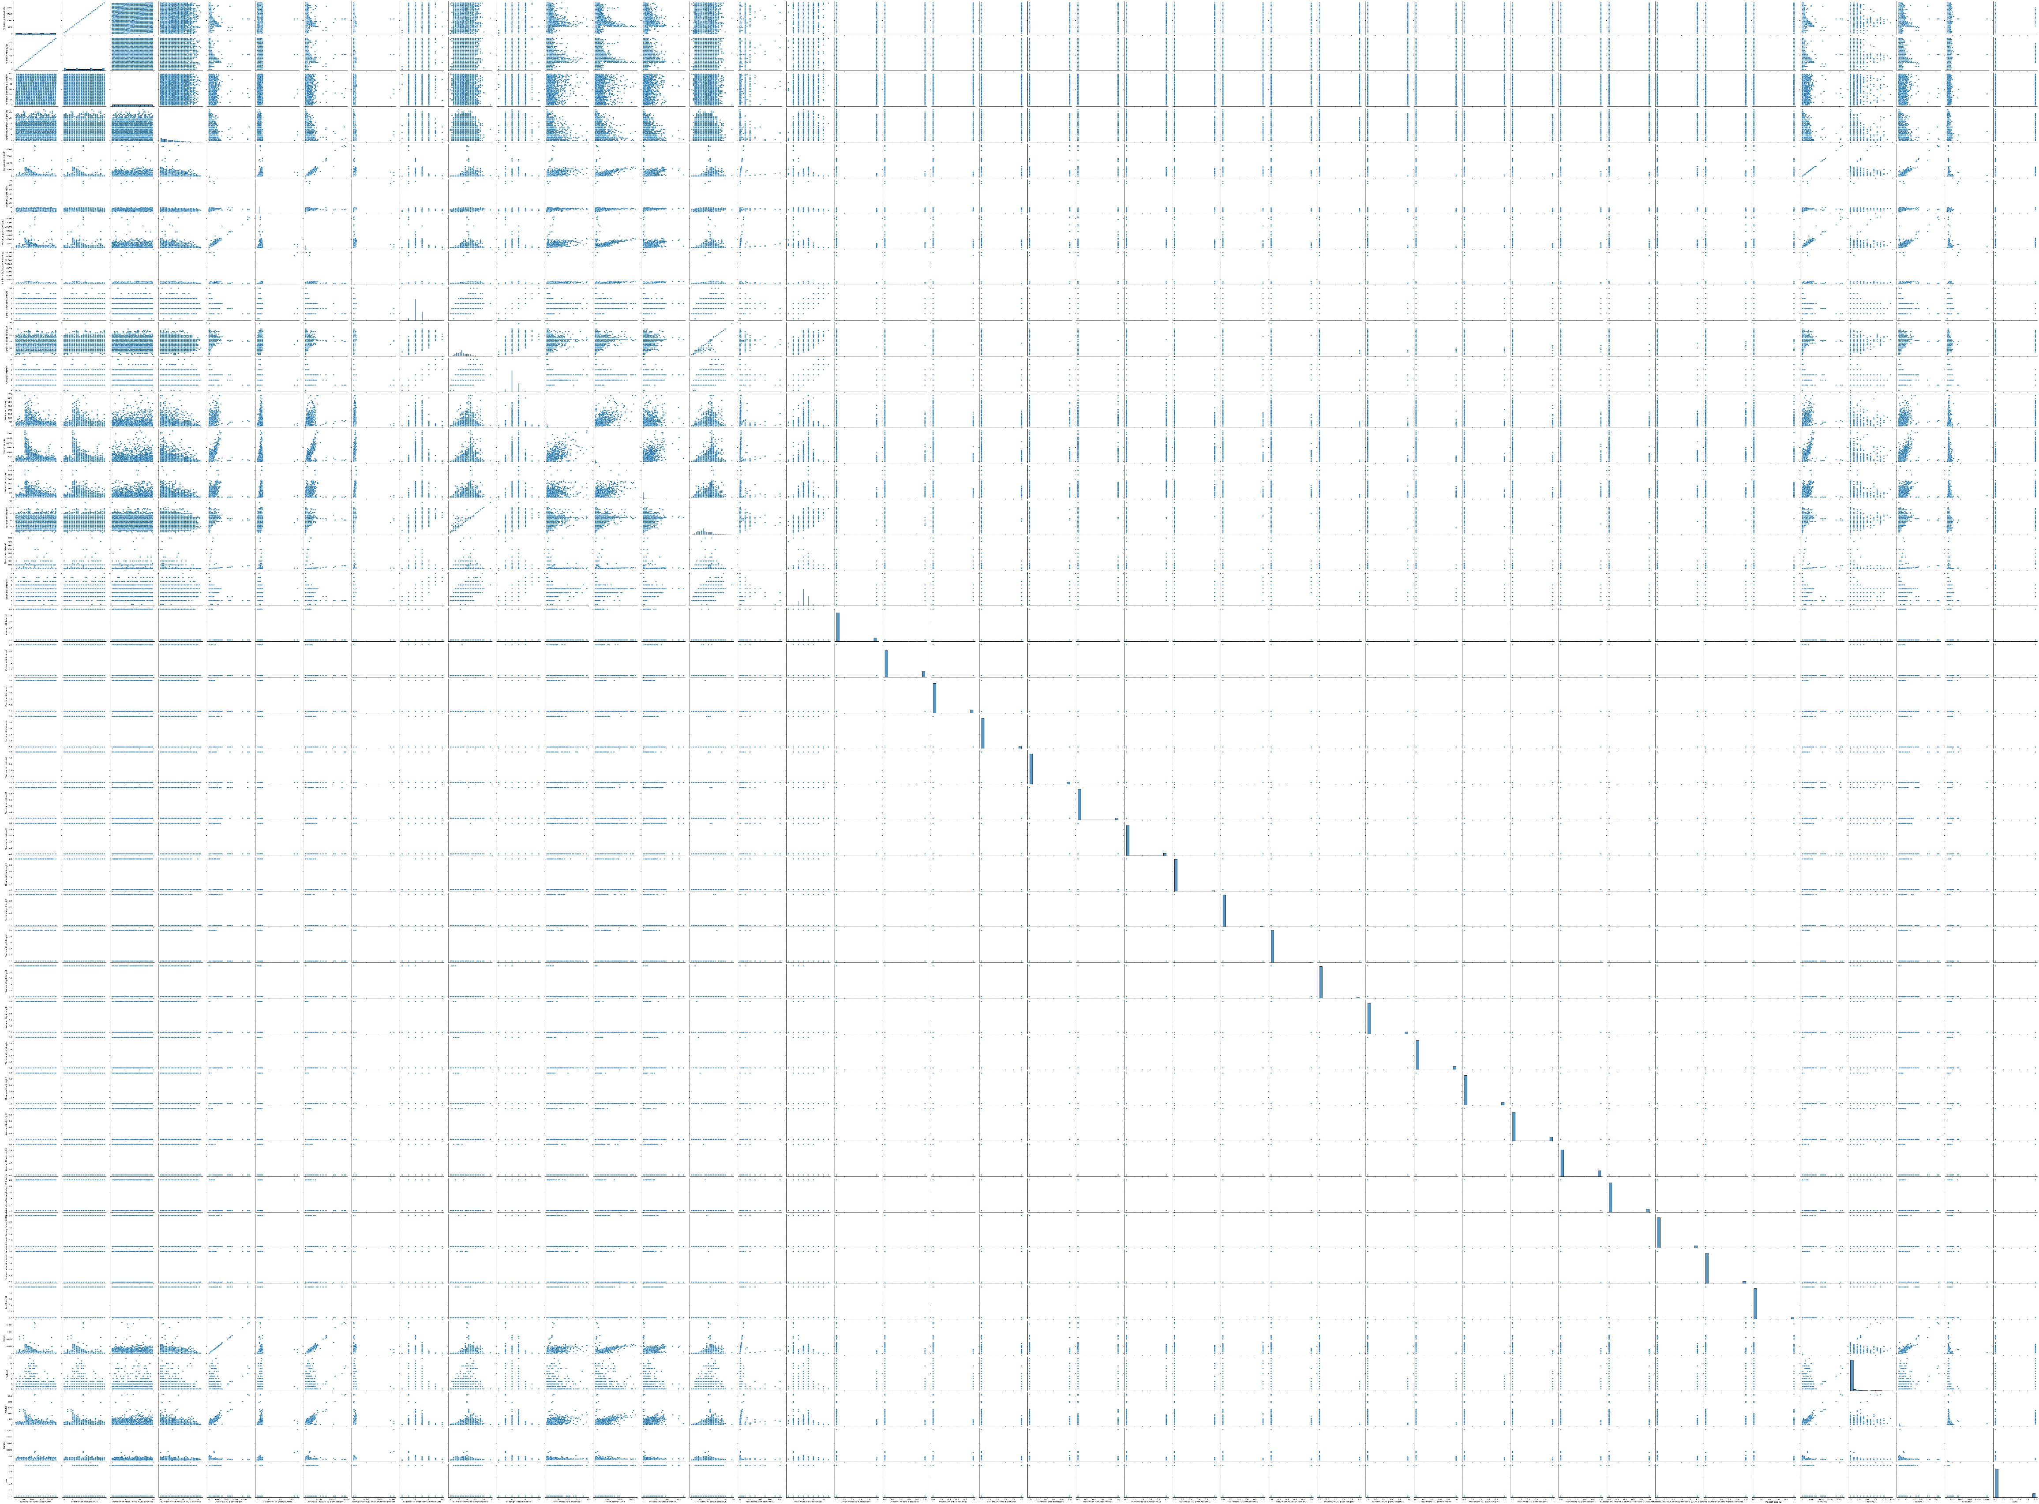

Figure 6: Visualizing the relationships between all features of the dataset using seaborn library of python

* 1. **RIPE_WannaCrypt**

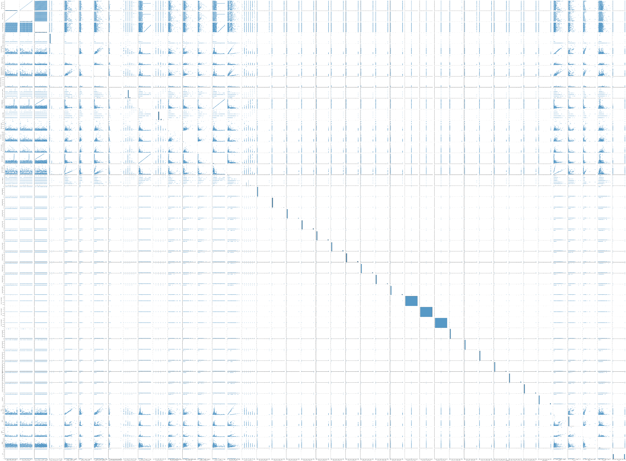

Figure 7: Visualizing the relationships between all features of the dataset using seaborn library of python

* 1. **RouteViews_Moscow_blackout**

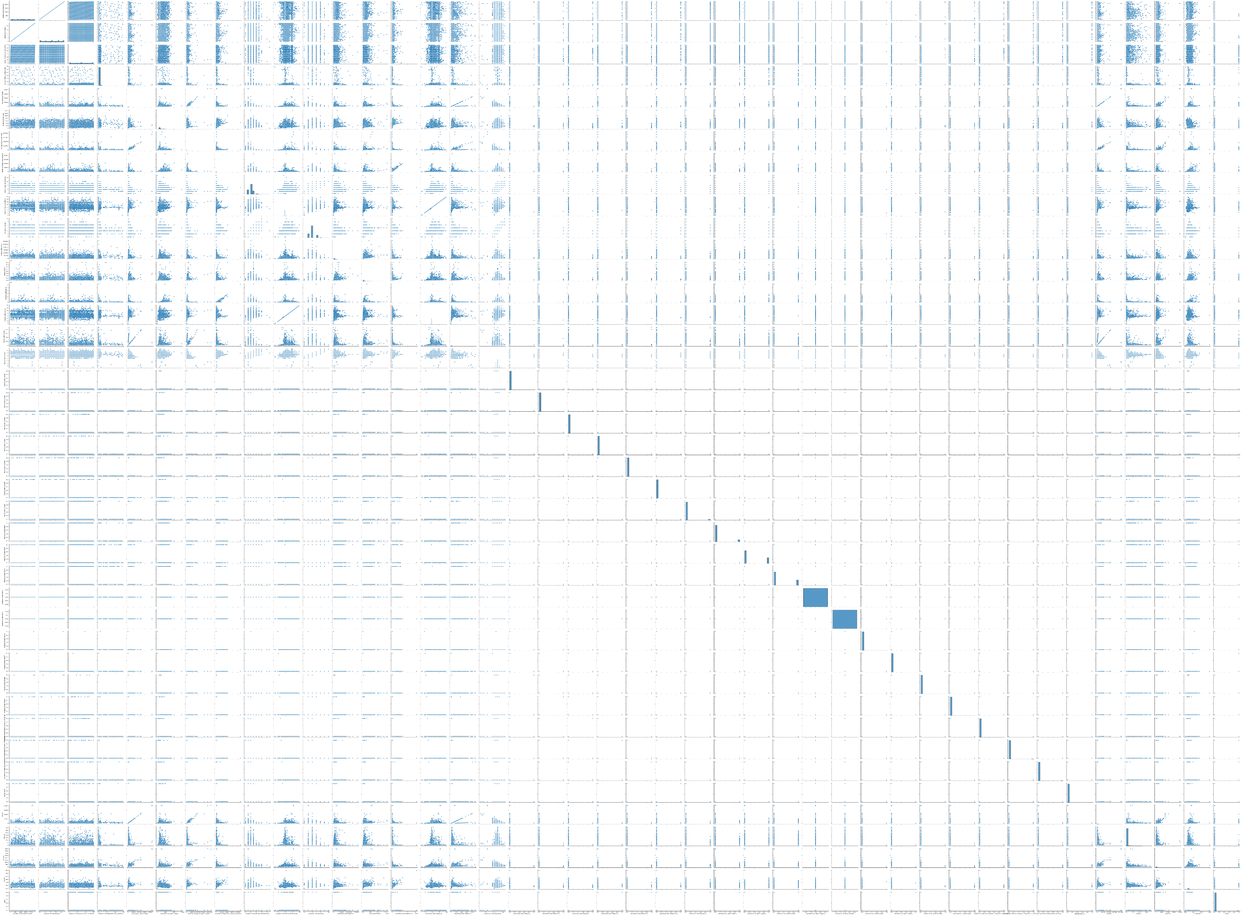

Figure 8: Visualizing the relationships between all features of the dataset using seaborn library of python

* 1. **RouteViews_Slammer**

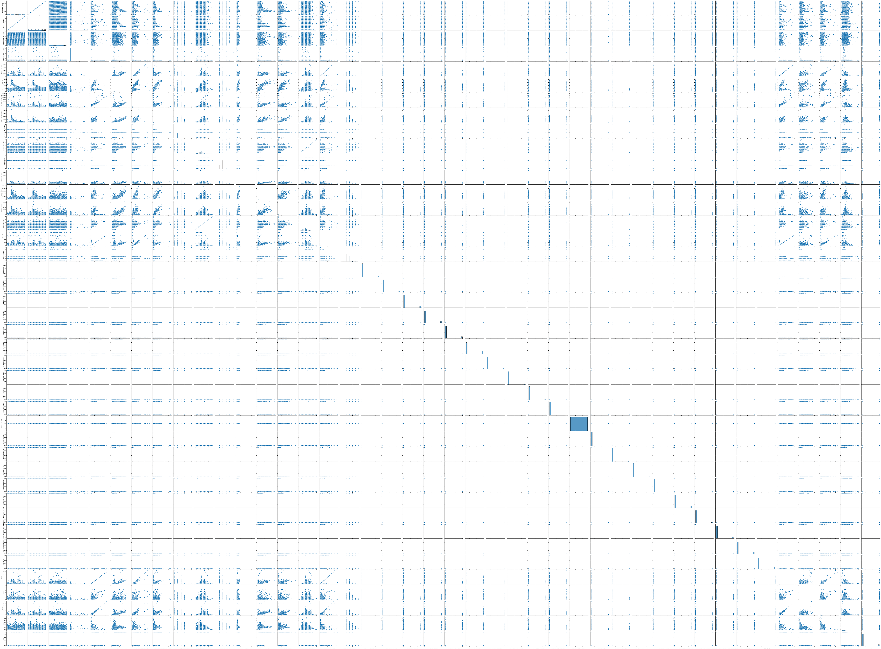

Figure 9: Visualizing the relationships between all features of the dataset using seaborn library of python

* 1. **RouteViews_WannaCrypt**

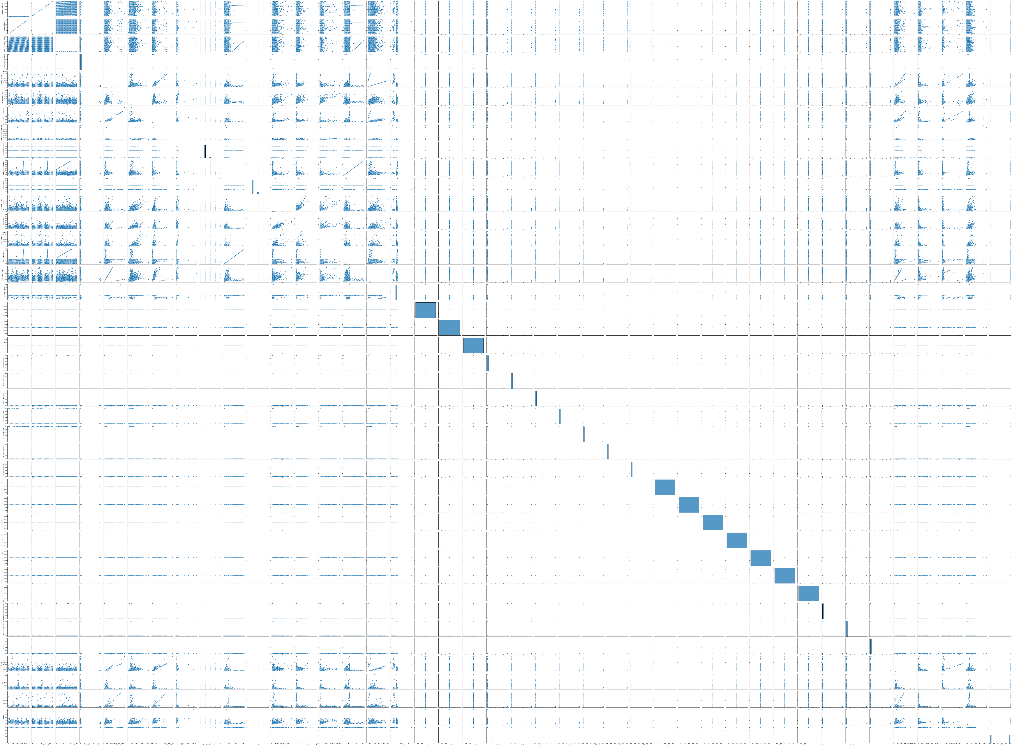

Figure 10: Visualizing the relationships between all features of the dataset using seaborn library of python

1. **Machine Learning algorithm:** I used Google Colab to perform my experiments. Logistic regression algorithm was used for classification purpose. The python code is as below:-

from sklearn.linear_model import LogisticRegression

import pandas as pd

import numpy as np

from google.colab import drive

drive.mount('/content/drive/')

*# Load the dataset*

data = pd.read_csv("/file path/file name.csv", header = None)

data.columns = ['Number of announcements', 'Number of withdrawals', 'Number of announced NLRI prefixes', 'Number of withdrawn NLRI prefixes', 'Average AS-path length', 'Maximum AS-path length', 'Average unique AS-path length', 'Number of duplicate announcements', 'Number of duplicate withdrawals', 'Number of implicit withdrawals', 'Average edit distance', 'Maximum edit distance', 'Inter-arrival time', 'Maximum edit distance1', 'Maximum edit distance2', 'Maximum edit distance3', 'Maximum edit distance4', 'Maximum edit distance5', 'Maximum edit distance6', 'Maximum edit distance7', 'Maximum edit distance8', 'Maximum edit distance9', 'Maximum edit distance10', 'Maximum edit distance11', 'Maximum AS-path length1', 'Maximum AS-path length2',

'Maximum AS-path length3', 'Maximum AS-path length4', 'Maximum AS-path length5', 'Maximum AS-path length6', 'Maximum AS-path length7', 'Maximum AS-path length8', 'Maximum AS-path length9', 'Number of Interior Gateway Protocol (IGP) packets', 'Number of Exterior Gateway Protocol (EGP) packets', 'Number of incomplete packets', 'Packet size (B)', 'Feature1', 'Feature2', 'Feature3', 'Feature4', 'Label' ]

data.Label.replace([1, -1], [1, 0], inplace=True)

data.isnull().sum().sum()

np.where(np.asanyarray(np.isnan(data)))

*# For data visualizing*

import seaborn as sns

import matplotlib.pyplot as plt

from mpl_toolkits.mplot3d import Axes3D

%matplotlib inline

*# Visualizing the relationships between features using pair plots*

sns.pairplot(data = data, height = 3)

*# Split the dataset into independent and dependent variables*

X = data.iloc[:, :40].values

y = data.iloc[:, 41].values

*# Split the dataset into training and testing sets*

from sklearn.model_selection import train_test_split

X_train, X_test, y_train, y_test = train_test_split(X, y, test_size=0.2, random_state=0)

*# Train the model*

from sklearn.linear_model import LogisticRegression

classifier = LogisticRegression(random_state=0)

classifier.fit(X_train, y_train)

from sklearn.pipeline import make_pipeline

from sklearn.preprocessing import StandardScaler

pipe = make_pipeline(StandardScaler(), LogisticRegression())

pipe.fit(X_train, y_train) # apply scaling on training data

pipe.score(X_test, y_test)

*# Predict the test set results*

y_pred = classifier.predict(X_test)

*# Evaluate the model using confusion matrix and accuracy score*

from sklearn.metrics import confusion_matrix, accuracy_score

cm = confusion_matrix(y_test, y_pred)

accuracy = accuracy_score(y_test, y_pred)

*# Visualizing confusion matrix*

group_names = ['True Neg','False Pos','False Neg','True Pos']

group_counts = ["{0:0.0f}".format(value) for value in cm.flatten()]

group_percentages = ["{0:.2%}".format(value) for value in cm.flatten()/np.sum(cm)]

labels = [f"{v1}\n{v2}\n{v3}" for v1, v2, v3 in zip(group_names,group_counts,group_percentages)]

labels = np.asarray(labels).reshape(2,2)

sns.heatmap(cm, annot=labels, fmt='', cmap='Blues')

1. **Results**
   1. **RIPE-BCNET_Regular:** Since this file has only non-anomalous packets, therefore it cannot be passed to machine learning algorithm.
   2. **RIPE-Code_Red_I**

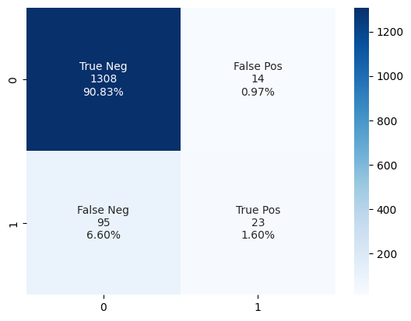

Figure 11: Visualizing confusion matrix of the results showing no. of packets correctly classified with percentages

* 1. **RIPE_Moscow_blackout**

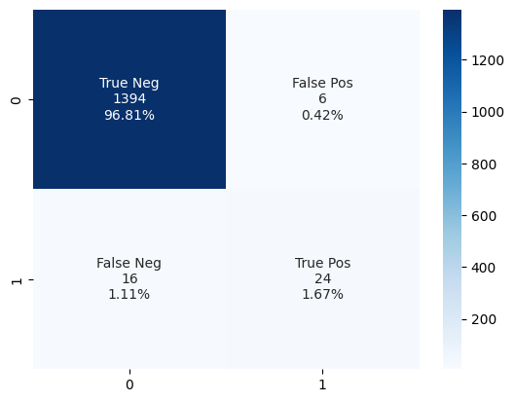

Figure 12: Visualizing confusion matrix of the results showing no. of packets correctly classified with percentages

* 1. **RIPE_Nimda**

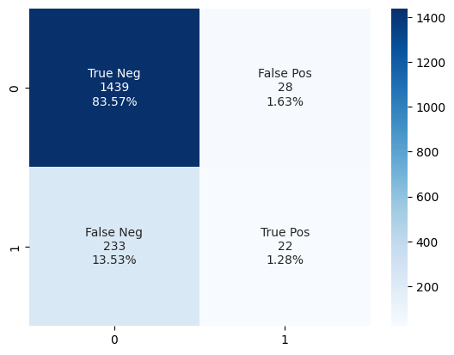

Figure 13: Visualizing confusion matrix of the results showing no. of packets correctly classified with percentages

* 1. **RIPE_regular:** Since this file has only non-anomalous packets, therefore it cannot be passed to machine learning algorithm.
  2. **RIPE_Slammer**

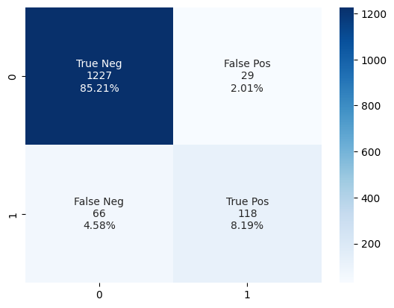

Figure 14: Visualizing confusion matrix of the results showing no. of packets correctly classified with percentages

* 1. **RIPE_WannaCrypt**

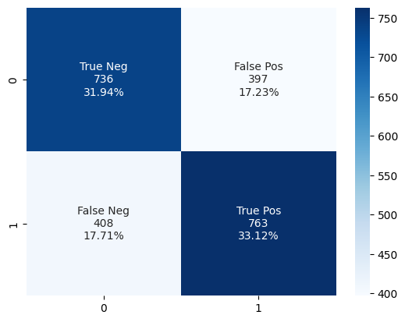

Figure 15: Visualizing confusion matrix of the results showing no. of packets correctly classified with percentages

* 1. **RouteViews_Moscow_blackout**

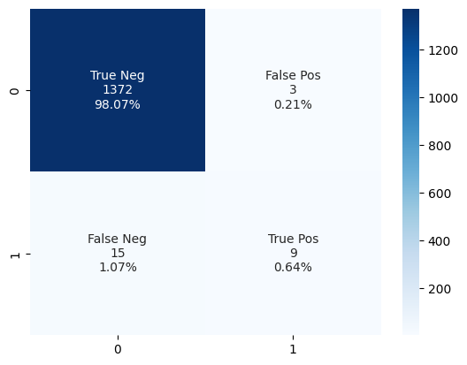

Figure 16: Visualizing confusion matrix of the results showing no. of packets correctly classified with percentages

* 1. **RouteViews_Slammer**

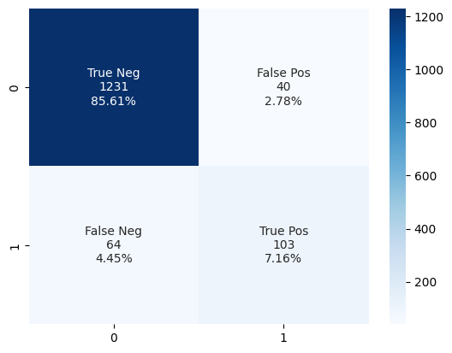

Figure 17: Visualizing confusion matrix of the results showing no. of packets correctly classified with percentages

* 1. **RouteViews_WannaCrypt**

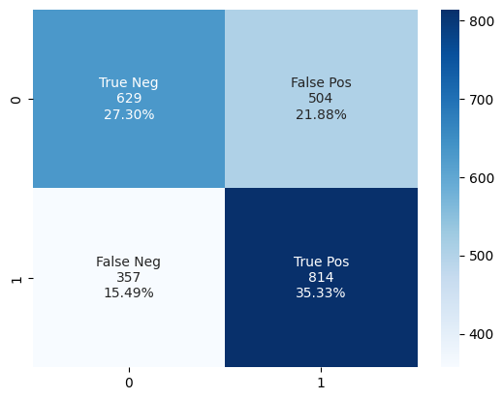

Figure 18: Visualizing confusion matrix of the results showing no. of packets correctly classified with percentages